**CSS**

CSS is a language that describes the style of an HTML document.

CSS describes how HTML elements should be displayed.

* **CSS** stands for **C**ascading **S**tyle **S**heets
* CSS describes **how HTML elements are to be displayed on screen, paper, or in other media**
* CSS **saves a lot of work**. It can control the layout of multiple web pages all at once

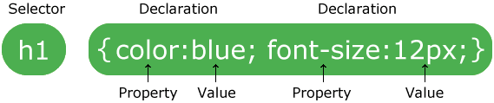

* To select an element with a specific id, write a hash (#) character, followed by the id of the element.

The class selector selects HTML elements with a specific class attribute.

To select elements with a specific class, write a period (.) character, followed by the class name.

.center {  
  text-align: center;  
  color: red;  
}

You can also specify that only specific HTML elements should be affected by a class.

p.center {  
  text-align: center;  
  color: red;  
}

**The universal selector (*)** selects all HTML elements on the page.

Example

The CSS rule below will affect every HTML element on the page:

* {  
  text-align: center;  
  color: blue;  
}

**The grouping selector** selects all the HTML elements with the same style definitions.

h1, h2, p {  
  text-align: center;  
  color: red;  
}

**External CSS** is the best way to insert css.

With an external style sheet, you can change the look of an entire website by changing just one file!

Each HTML page must include a reference to the external style sheet file inside the <link> element, inside the head section.

**rgb** (red, blue green) each color from 0 to 255

**The rgba()** function define colors using the Red-green-blue-alpha (RGBA) model.

rgba (red, blue green, alpha ) alpha it’s 0 or 1 Defines the opacity as a number between 0.0 (fully transparent) and 1.0 (fully opaque)

**solid** will create a black line